

**Project Title: Customer Segmentation and Car Preference Analysis for Optimizing Marketing Strategy A Case Study of Austo Motor Company**

**Domain: Automotive & Marketing Analytics**

Tools Used – Python (Numpy, Pandas, Matplotlib Library, Seaborn Library)

**Objective:**  
To analyze the automobile market data of Austo Motor Company to identify customer segments, understand preferences for car models (SUV, Sedan, Hatchback), uncover key behavioral and income-based trends, and provide actionable strategies to improve marketing efficiency, increase sales, and align product offerings with buyer expectations.

**Made By – Abhijeet Beura**

Austo Motor Company is a leading car manufacturer specializing in SUV, Sedan, and Hatchback models. In its

recent board meeting, concerns were raised by the members on the efficiency of the marketing campaign

currently being used. The board decides to rope in analytics professional to improve the existing campaign.

Imported the libraries for the Data are

Numpy

Pandas

Matplotlib

Seaborn

1. There are some information about the dataset, decision makers should have a look.

The dataset is having 1581 rows and 14 columns.

There is a look on the 5 sample rows to check the data type.

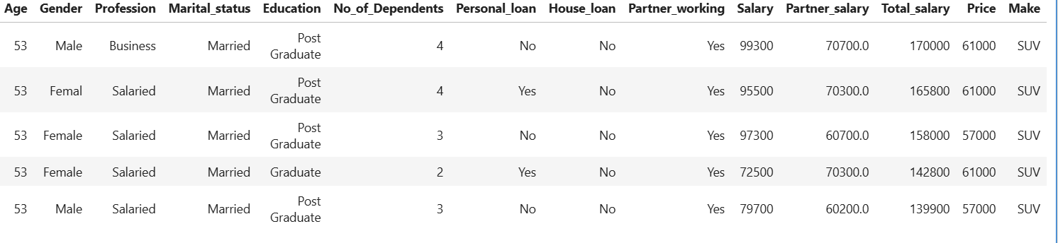

**Table 1: Top five rows of the dataset**

2. While having a look on the data set information, it is found that there are 6 numerical and 8 categorial variables. The below table contains the same information.

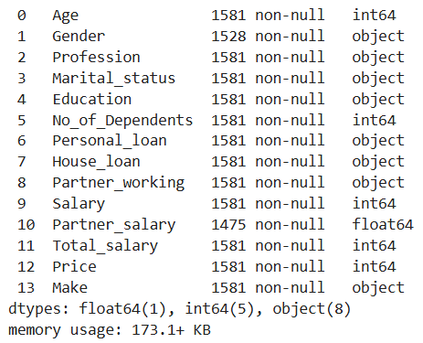

**Table 2: Basic information of the data type**

**3. Checking the data information.**

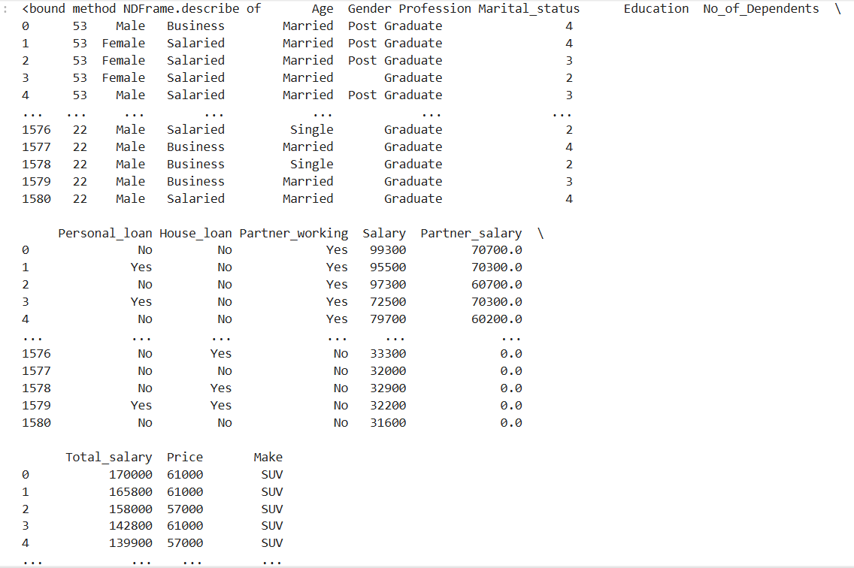

**Table 3: Basic information of the data**

4. Checking the columns of the dataset, to get the name of the variables.

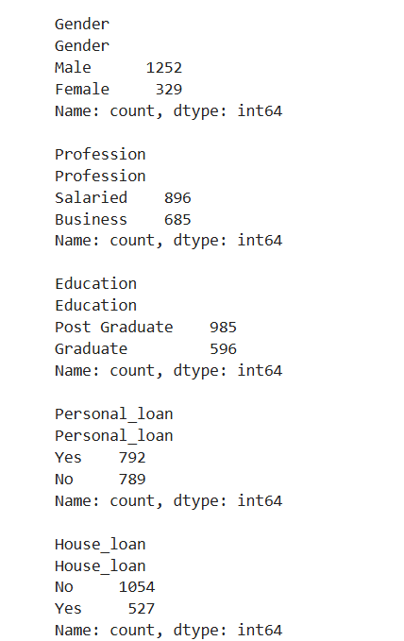

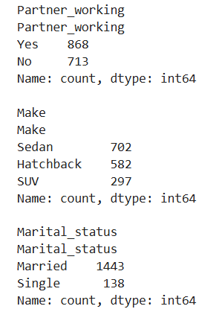

Table 4: Name of the columns present in the dataset

5. Checking the null values:

There are nulls in ‘Gender’ and ‘Partner_salary’ variables.

In ‘Gender’ it is found that there are total 53 null values.

In ‘Partner_salary’ it is found that there are total 106 null values.

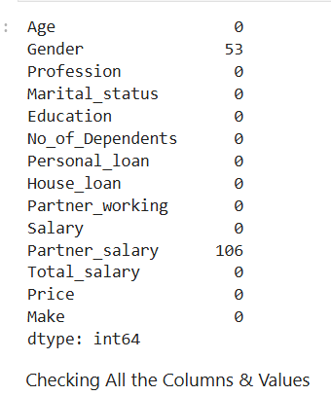

Table 5: Inspecting null values in the dataset

In order to treat the nulls in the ‘Partner_salary’, we have checked where the ‘Total_salary’

is greater than ‘Salary’.

Then we applied condition that,

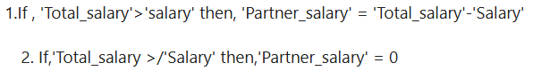

7. Checking the values count of ‘Gender’, and found that

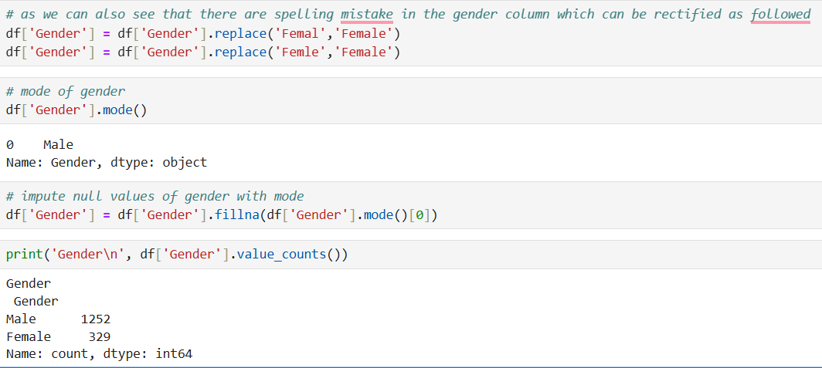

**Table 7: After imputing the Gender**

8. Now we are to have a look on statistical summery of the numeric variables of the dataset.

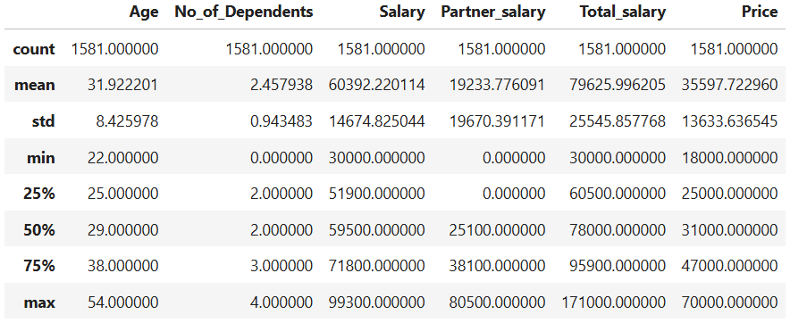

**Table 8: Statistical summary of numeric variables**

Table 9: Value counts of categorial variables

Checking for the outliers or extreme values.

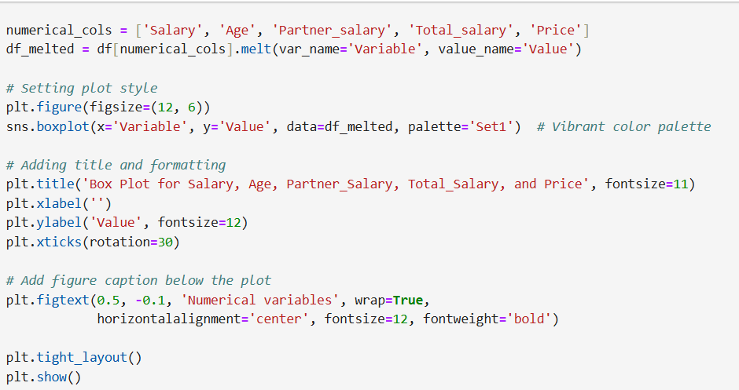

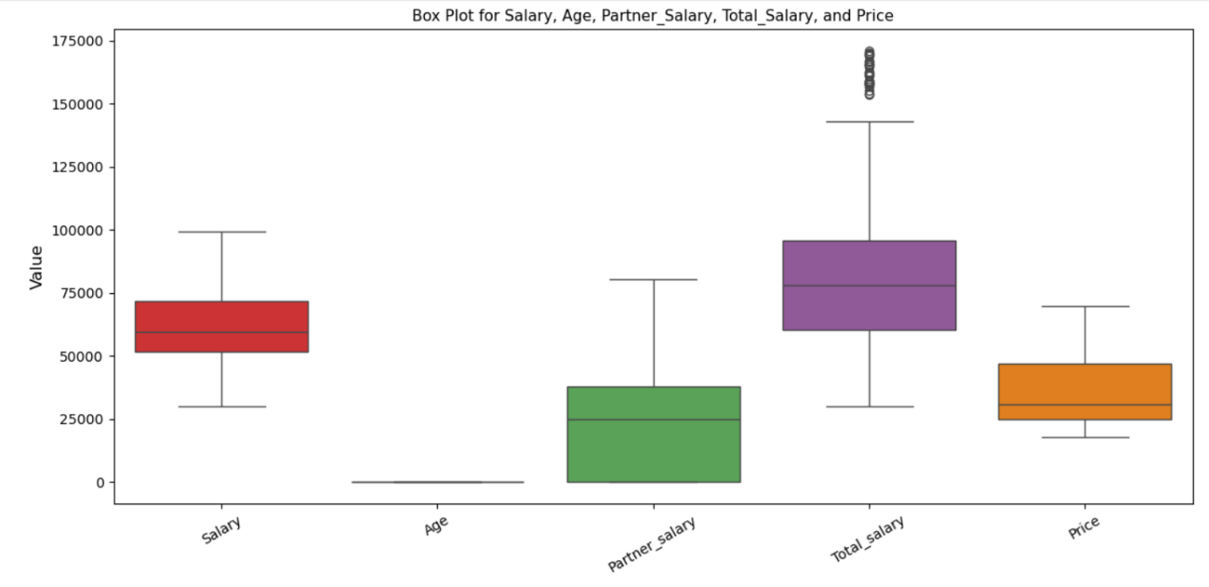

**Figure-1 : Box plots of numerical variables**

Analyzing box plots of every numerical variables separately:

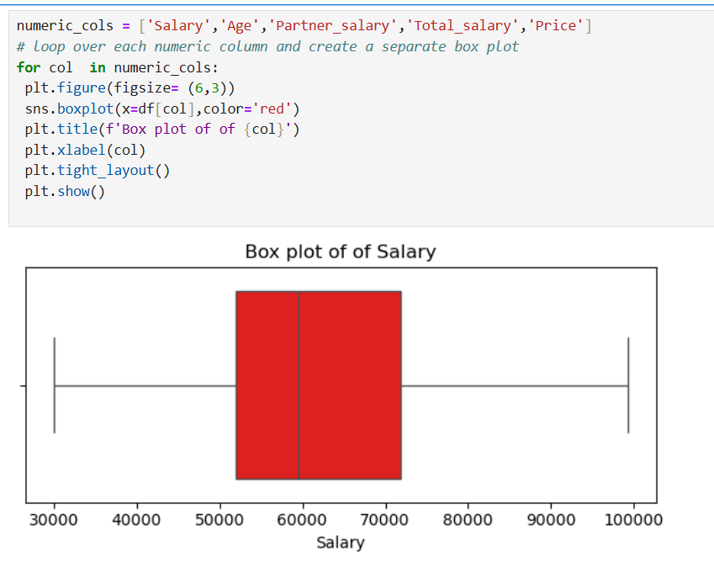

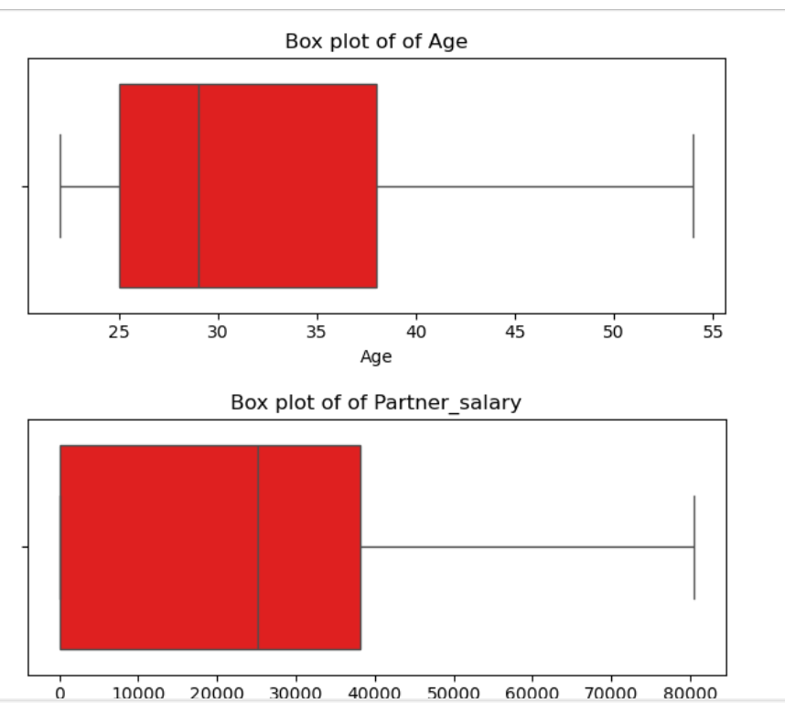

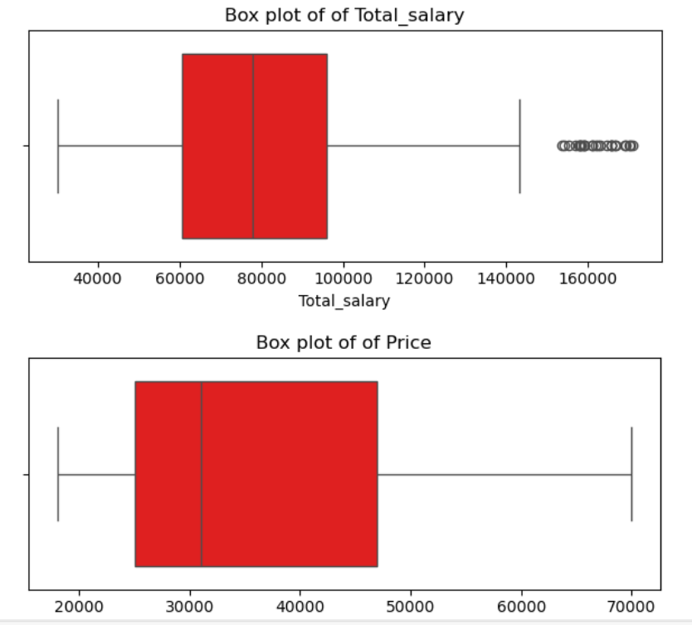

Figure-2 : Box plots of numerical variables individually 1. We can see that there are no negative values present in any numerical category. 2. The ‘Total_salary’ is having outlier.

Univariate analysis of numerical variables.

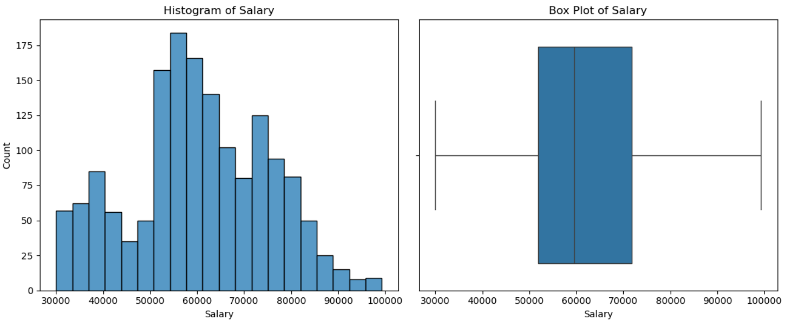

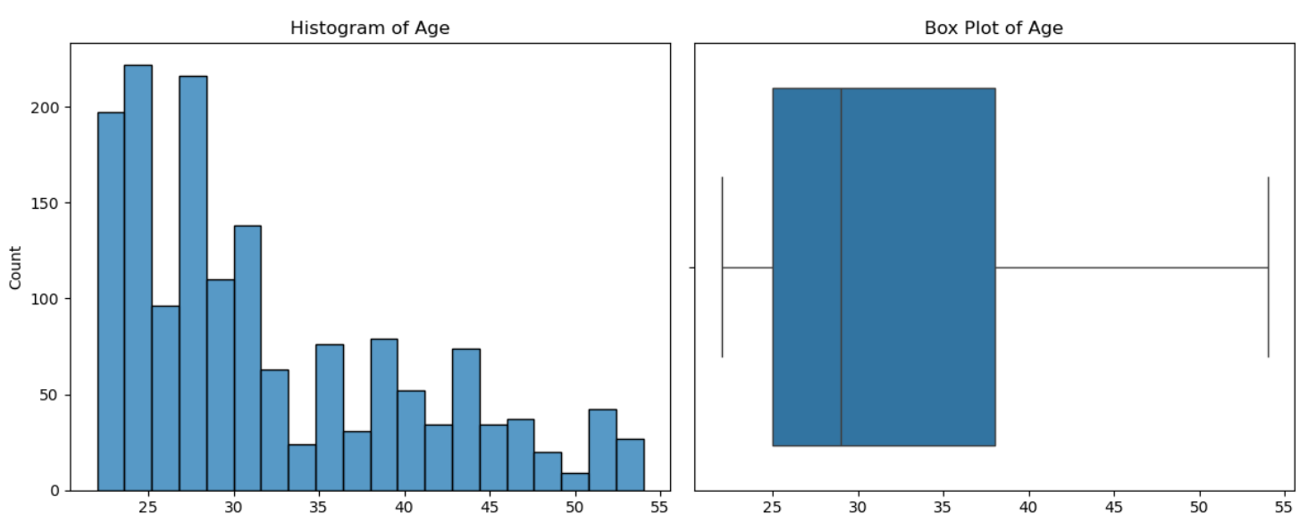

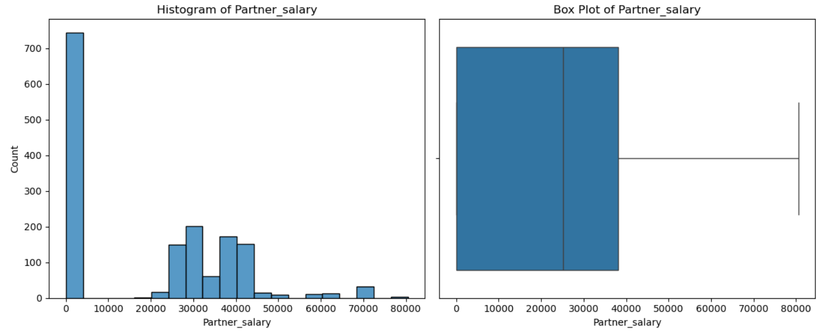

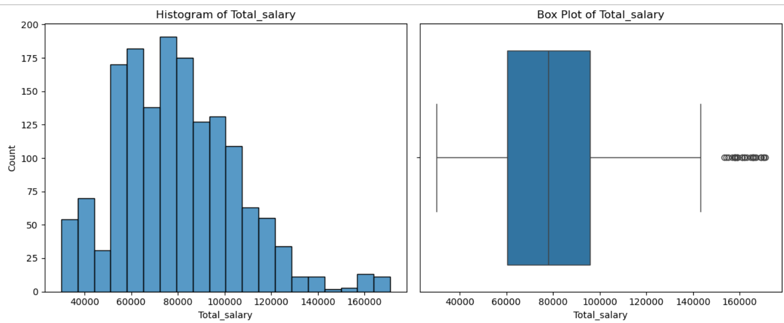

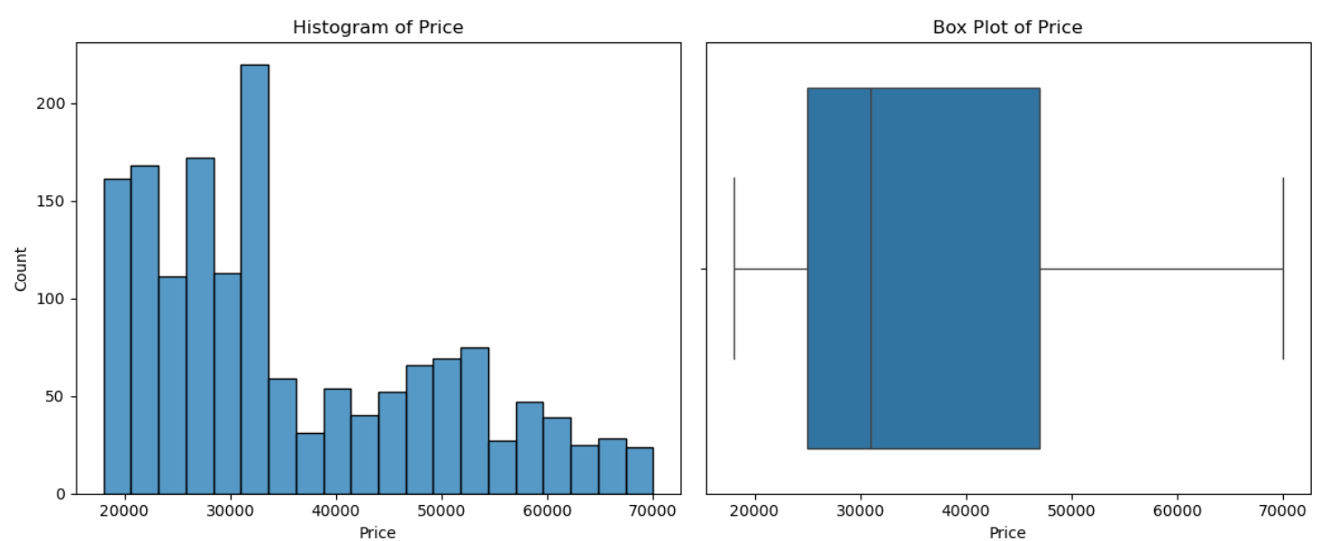

**Univariate analysis of numerical variables Inferences: 1. Salary has a range between 50k to 70k. 2. Total salary has a range between 60k to 100k.**

Univariate analysis of categorial

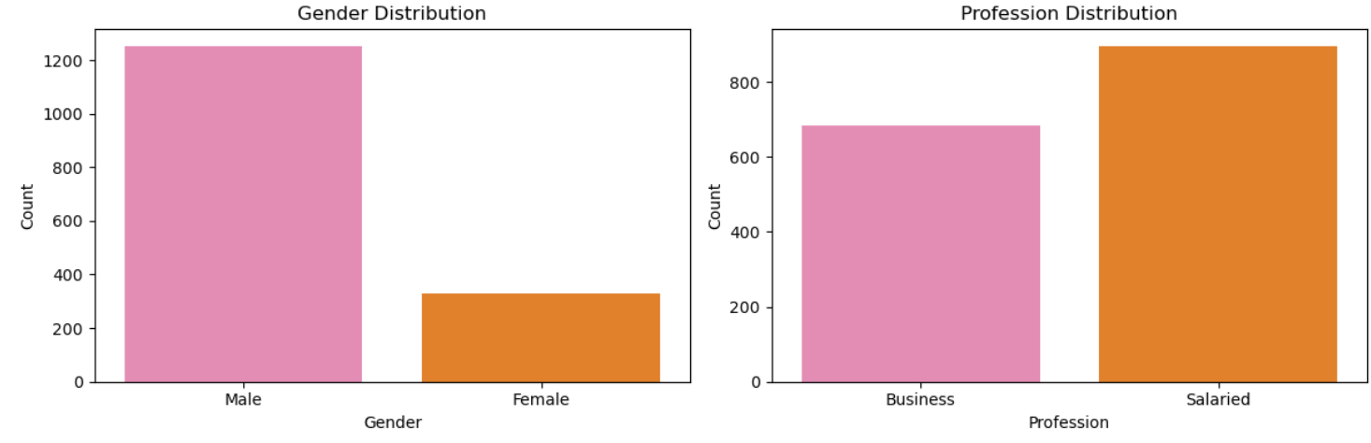

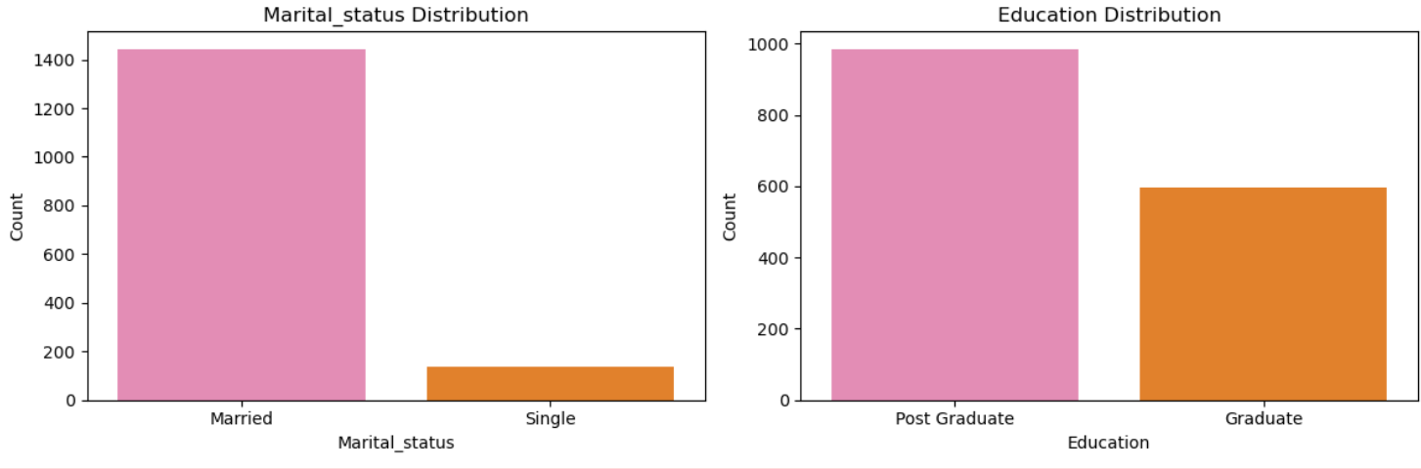

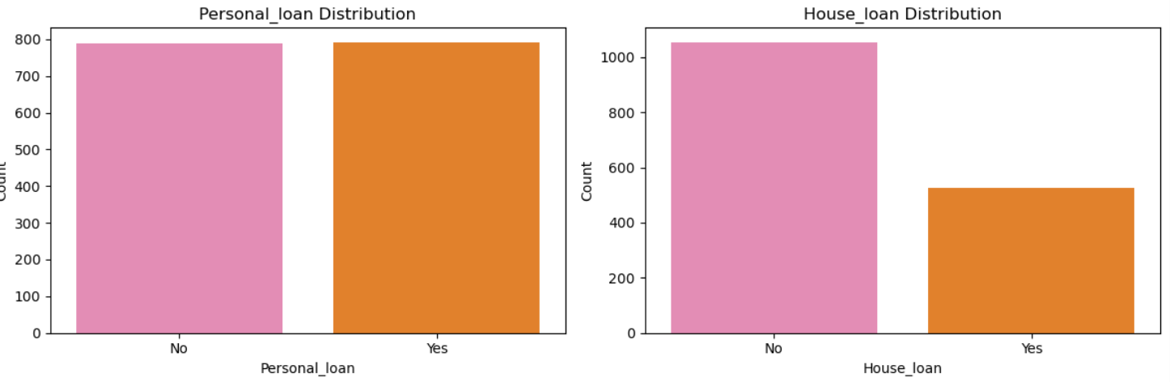

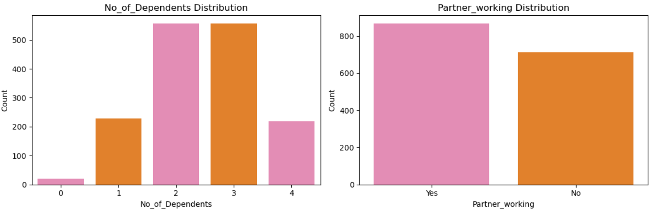

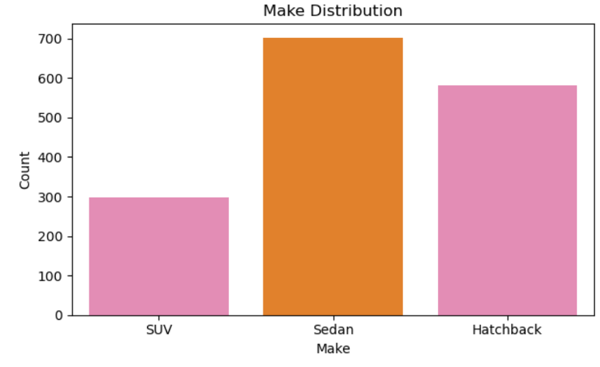

**Univariate analysis of categorial variables**

Inferences:

1. Sedan is most preferred, after Hatchback and SUV respectively.

2. The buyers with working partner are higher than the buyers with non-working partners or single

status.

3. The married buyers are very higher than the single status.

4. Major of the buyers are having postgraduate.

5. Buyers having business are little less than the number of buyers being salaried.

6. The buyers with having 2-3 dependents are higher in the dataset. Then comes the buyers with 1 & 4

dependents and the buyers having 0 dependents are very less.

Bivariate analysis of all the numerical variables

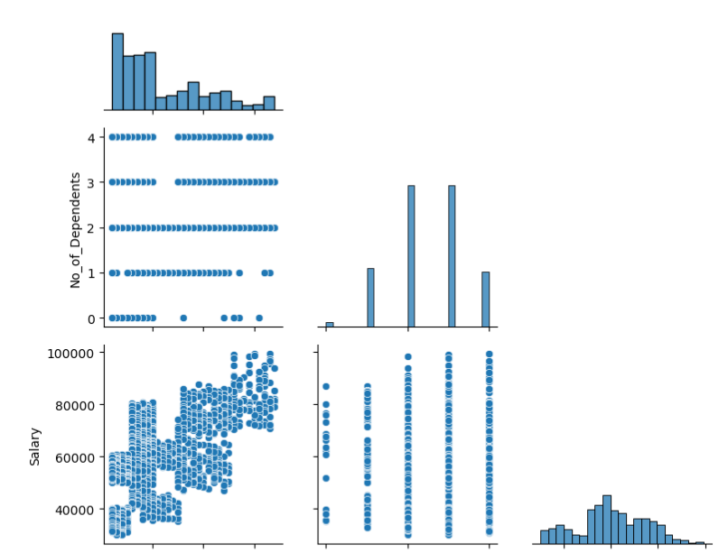

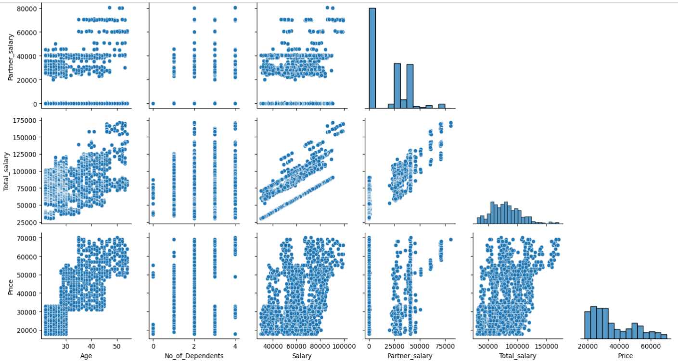

**Pair plot of the dataset numerical variables**

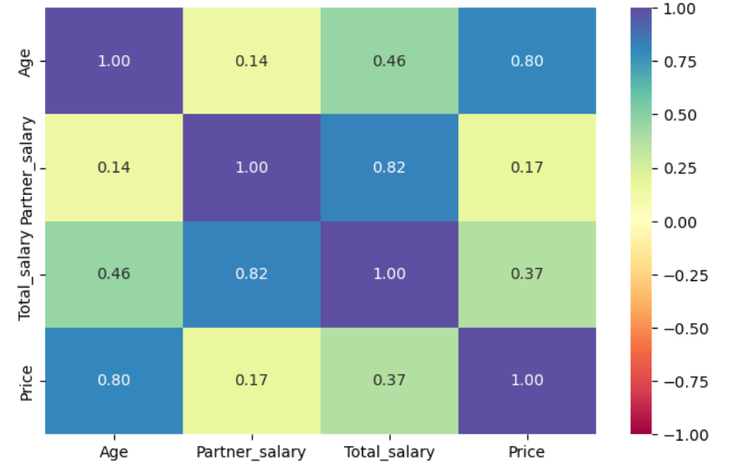

**Correlation heatmap of numerical variables**

Bivariate analysis of all the categorial vs numerical variables.

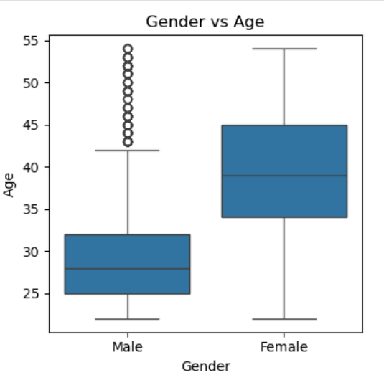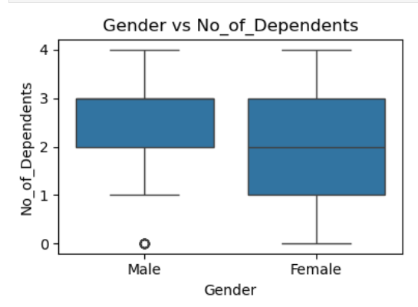

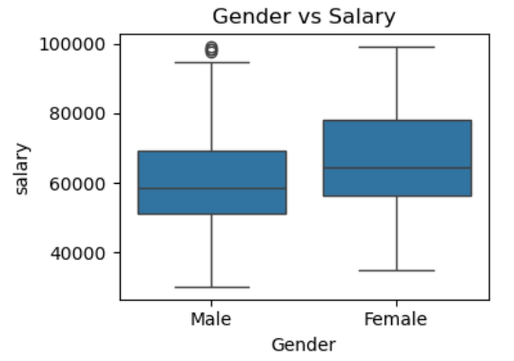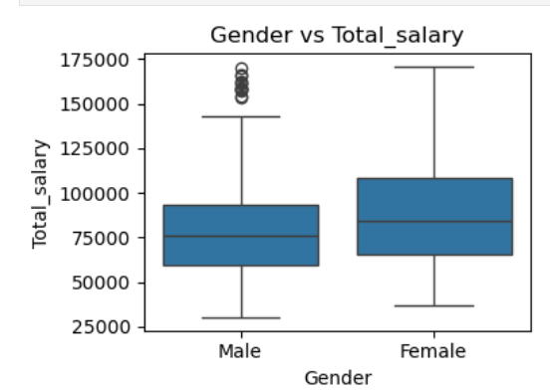

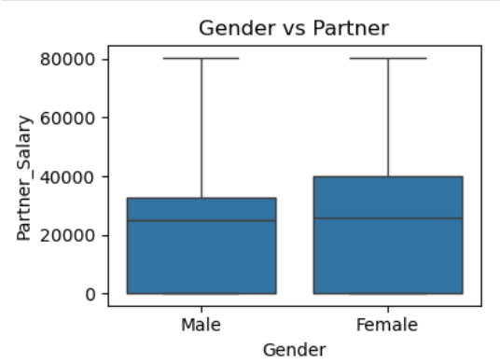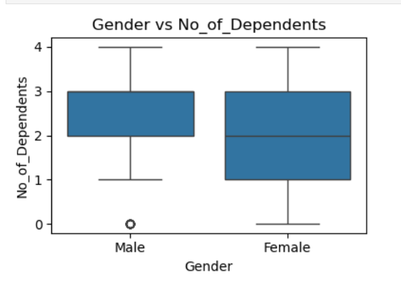

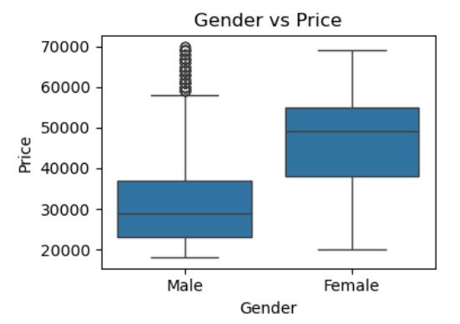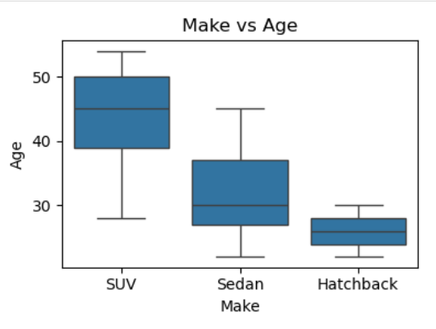

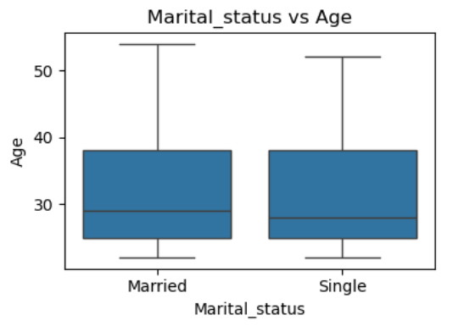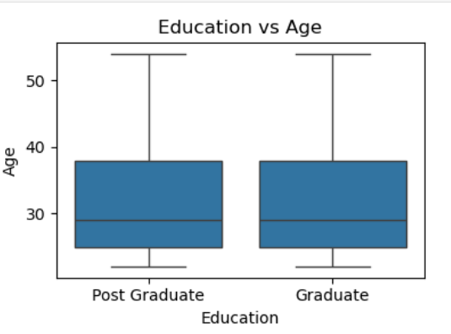

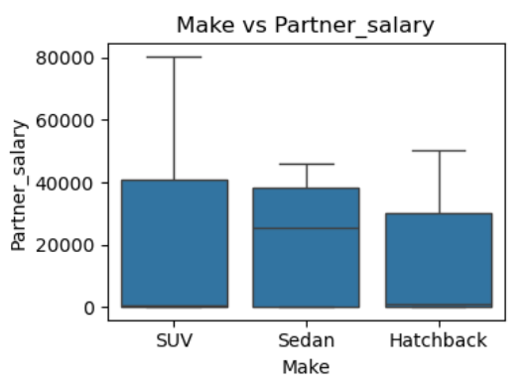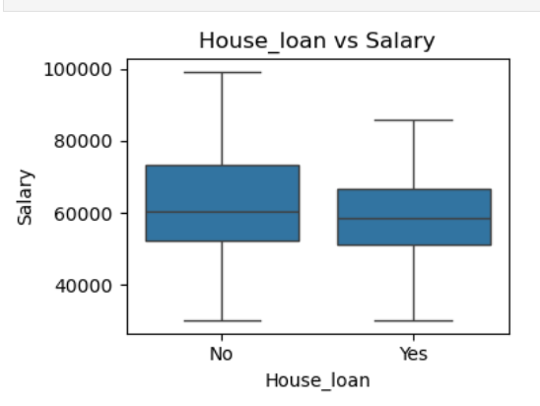

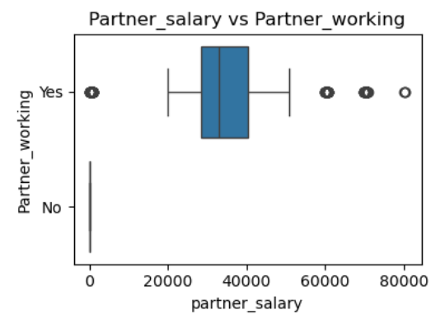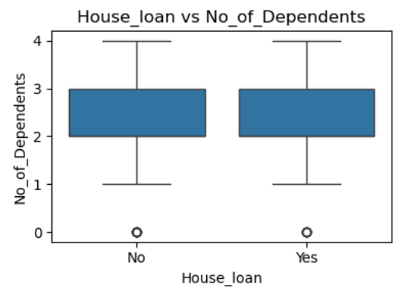

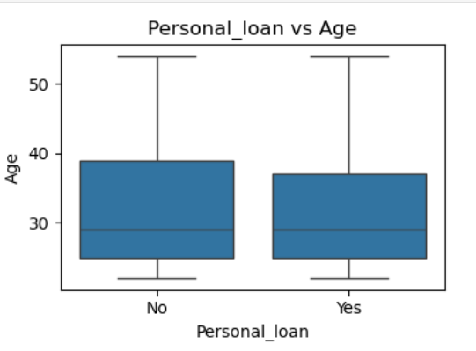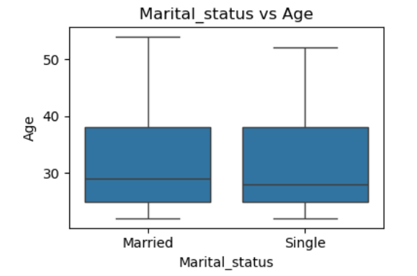

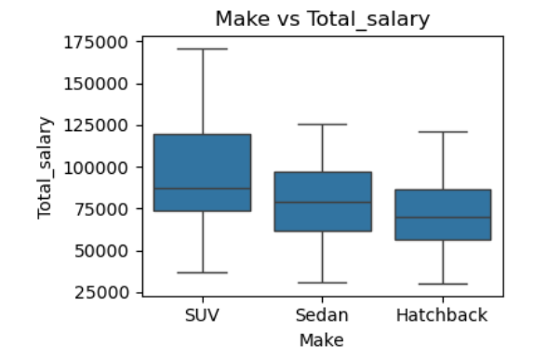 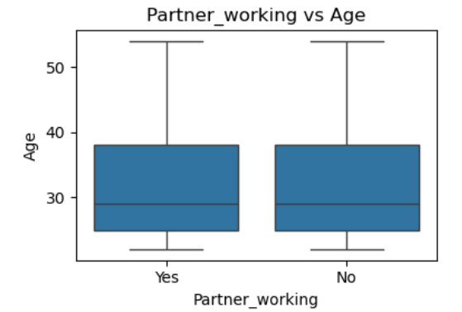

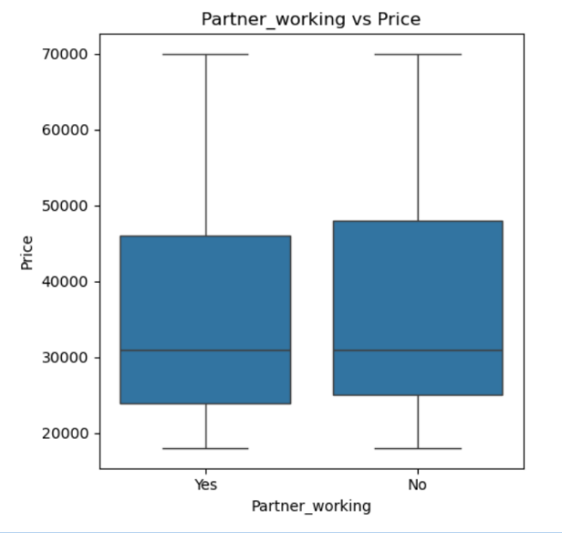 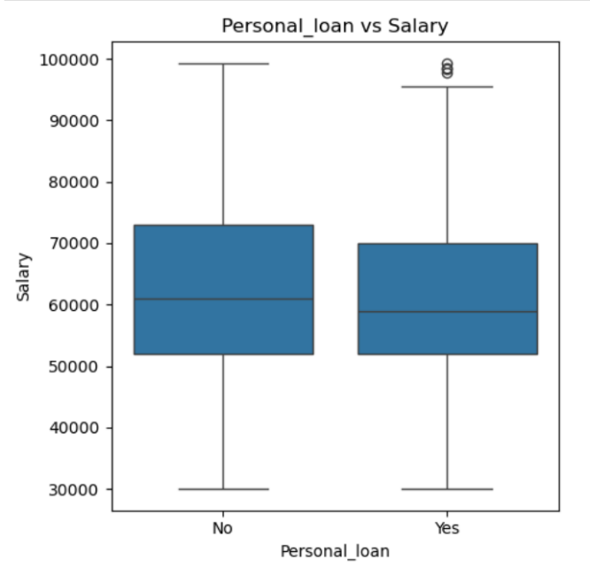

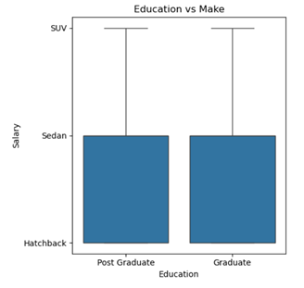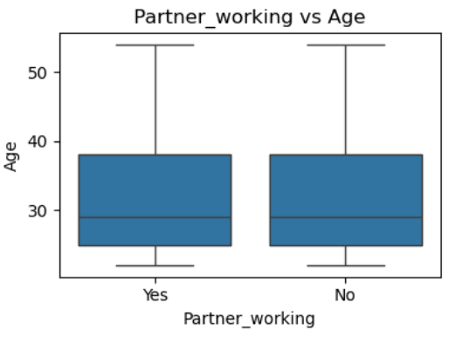

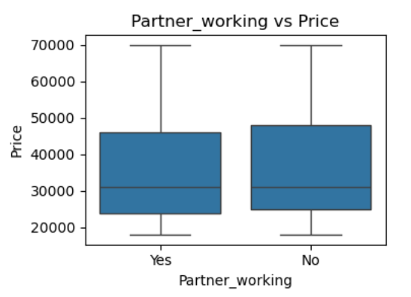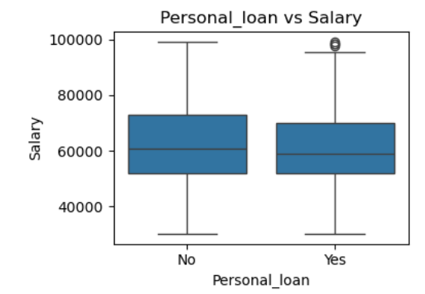

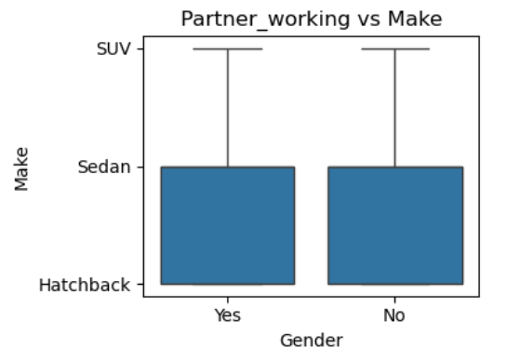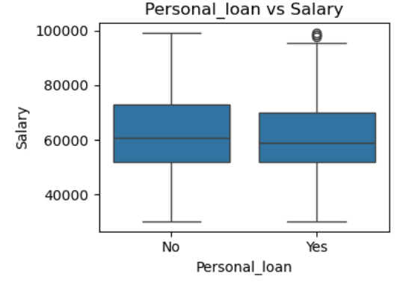

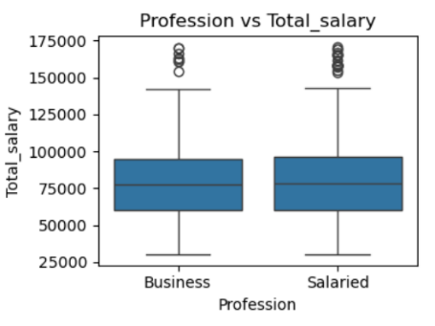

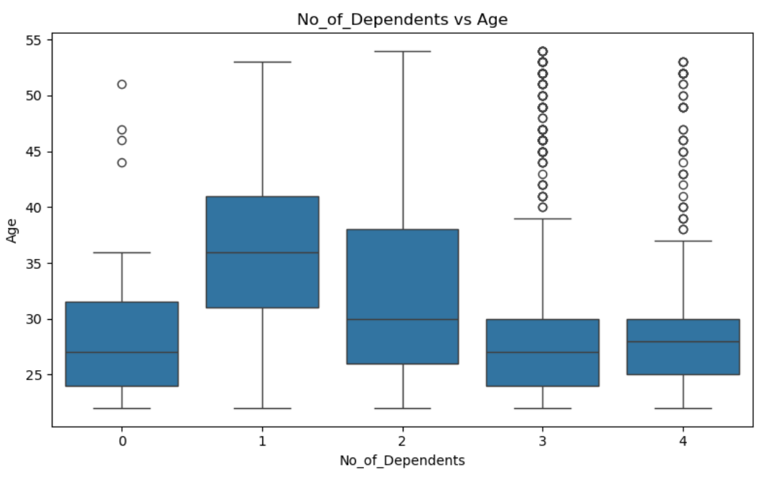

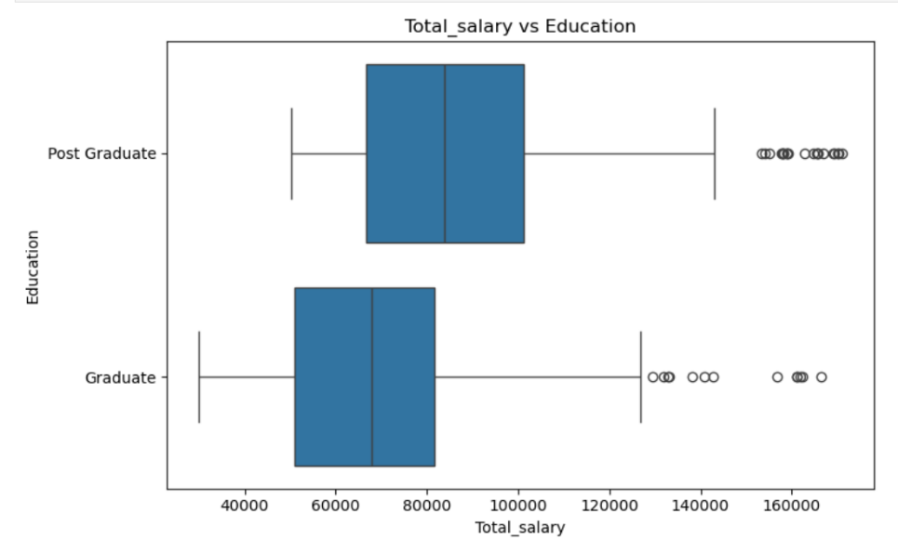

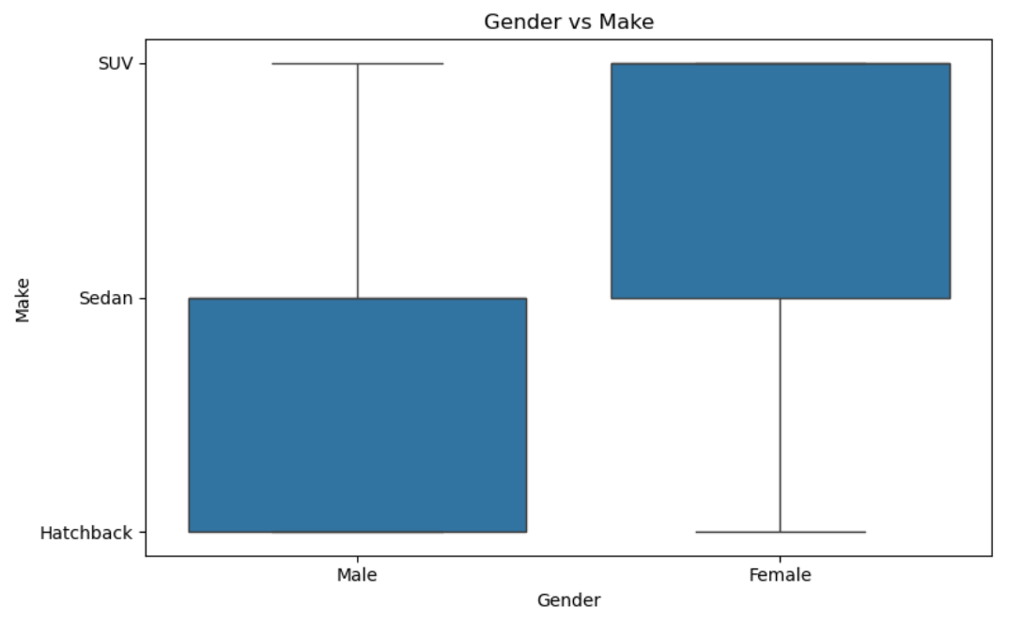

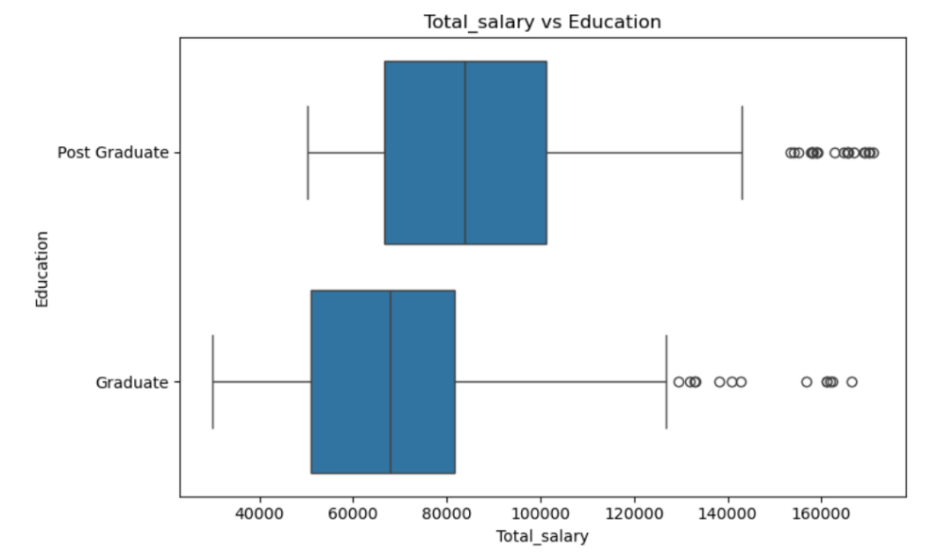

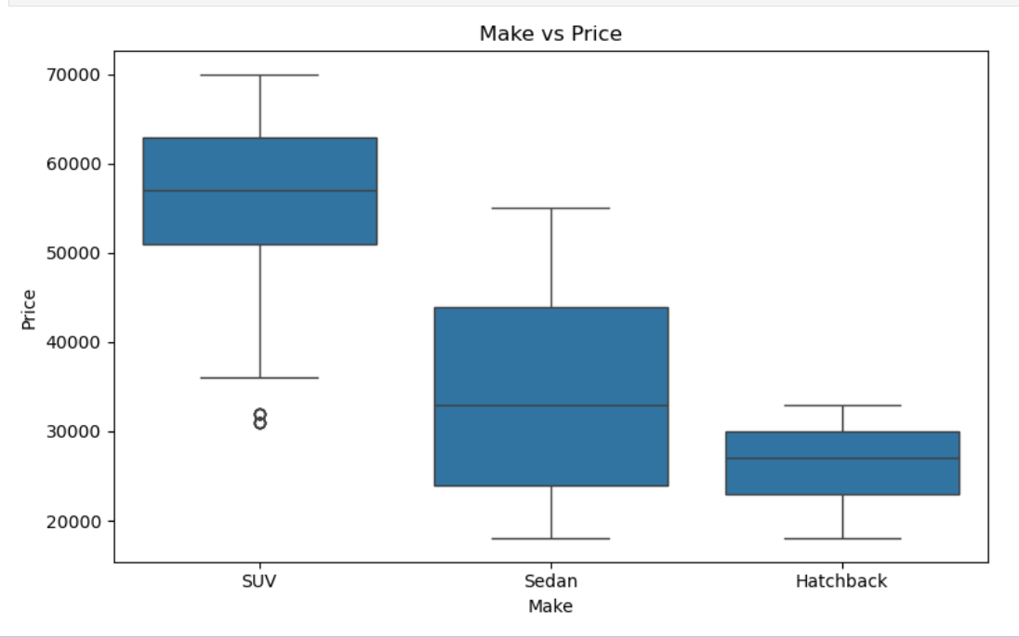

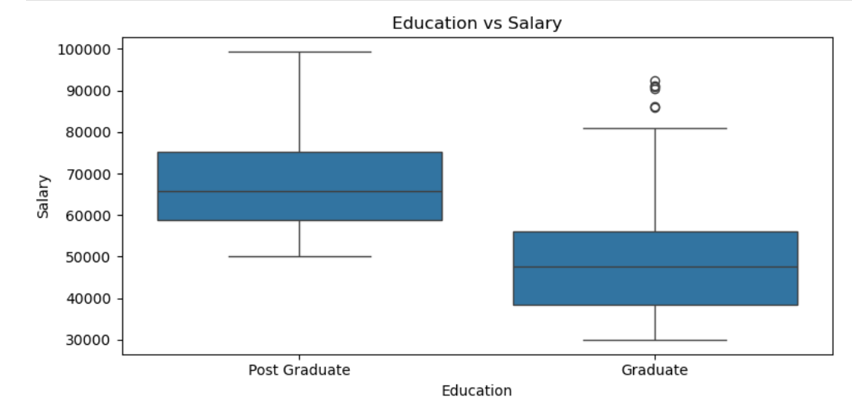

**Bivariate relationship of categorial vs numerical variables**

**Gender-Based Insights**

* Age: Females are generally older than males.
* Dependents:
  + Females: Mostly have 1–3 dependents
  + Males: Commonly have 2–3 dependents
* Salary Range:
  + Females: ₹34,800 – ₹99,300
  + Males: ₹30,000 – ₹99,300  
     *Females have a higher minimum salary.*
* Partner Salary: Slightly higher among females.
* Total Salary: Higher for females than males.
* Automobile Price: Females tend to purchase higher-priced cars.

**Profession-Based Insights**

* Salaried buyers are generally older than business buyers.
* Dependents: Both salaried and business buyers mostly have 2–3 dependents.
* Own Salary: Slightly higher for salaried buyers.
* Partner Salary: Slightly higher among salaried buyers (not significant).
* Total Salary: More outliers seen in salaried buyers indicates income diversity.
* Automobile Spending: Salaried buyers spend more on cars than business buyers.

**Marital Status Insights**

* Age: Married and single buyers fall in a similar age group.
* Dependents: Some singles have 1 dependent.
* Salary: Roughly similar between married and single buyers.
* Total Salary: Higher for married buyers.
* Automobile Spending: Married buyers spend more on cars.

**Education-Based Insights**

* Age: Graduates and postgraduates are in a similar age bracket.
* Dependents: Both mostly have 2–3 dependents.
* Salary: Higher for postgraduates.
* Partner Salary: Slightly higher for graduates.
* Total Salary: Higher for postgraduates.
* Car Spending: Surprisingly, graduates spent more on cars.

**Loan & Salary-Based Insights**

* Buyers with salary > ₹70,000 have not taken personal loans.
* Buyers with 2–3 dependents are more likely to have house loans.
* Buyers with a working partner have a higher total salary.

**Car Type Preferences**

By Age Group:

* SUV: Preferred by 38–50 years
* Sedan: Preferred by 27–37 years
* Hatchback: Preferred by 25–28 years

By Dependents:

* SUV & Hatchback: Buyers with 2–3 dependents
* Sedan: Buyers with 1–3 dependents

By Salary Range:

* SUV: ₹62,000 – ₹82,000
* Sedan: ₹52,000 – ₹68,000
* Hatchback: ₹44,000 – ₹66,000

By Total Salary:

* SUV: ₹66,000 – ₹1,20,000
* Sedan: ₹64,000 – ₹88,000
* Hatchback: ₹60,000 – ₹84,000

By Car Price:

* SUVs: ₹52,000 – ₹64,000
* Sedans: ₹26,000 – ₹44,000
* Hatchbacks: ₹24,000 – ₹30,000

**Do men tend to prefer SUVs more compared to women?**

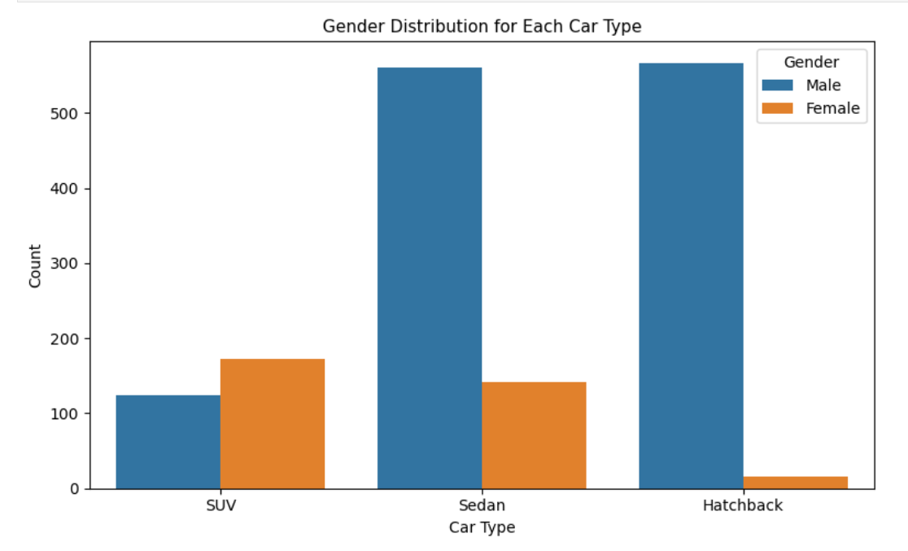

**Count plot of Gender vs Make**

We can properly see that the women more likely prefer SUVs compared to men.

So, the answer for the Question is ‘No’.

**What is the likelihood of a salaried person buying a Hatchback?**

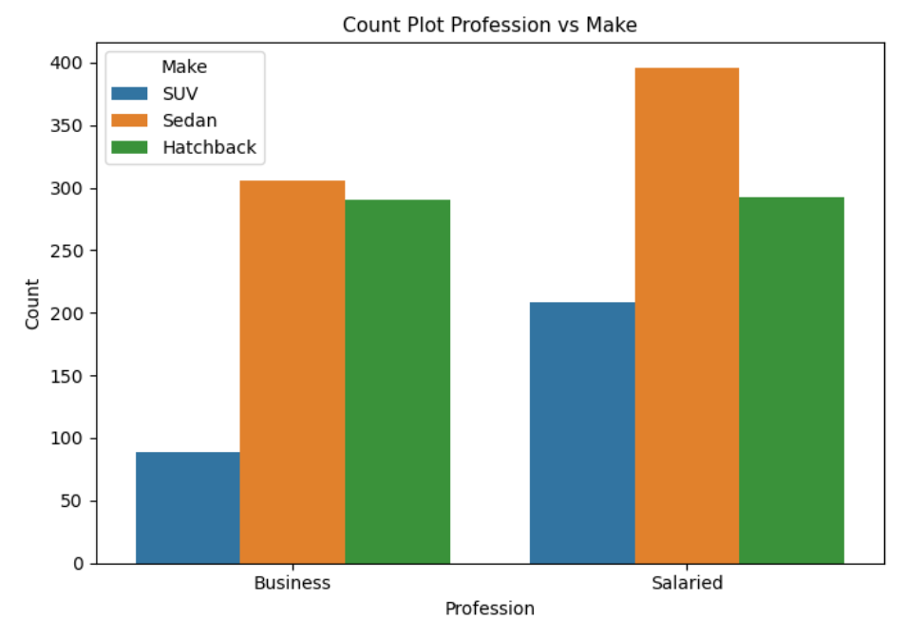

**Count plot of Profession vs Make**

Salaried individuals are more likely to purchase Hatchbacks as their second preference after Sedans. This suggests a balance between comfort and cost-effectiveness in their purchasing decisions.

**Which car is least choice of salary person & Business ?**



SUV is the least choice Car by both salary person & Business Person because SUV Car cost is more as compared to Other Cars that main Reason People Like to Buy other Cars.

**Which Car Is most Liked my Female in Salary Category ?**

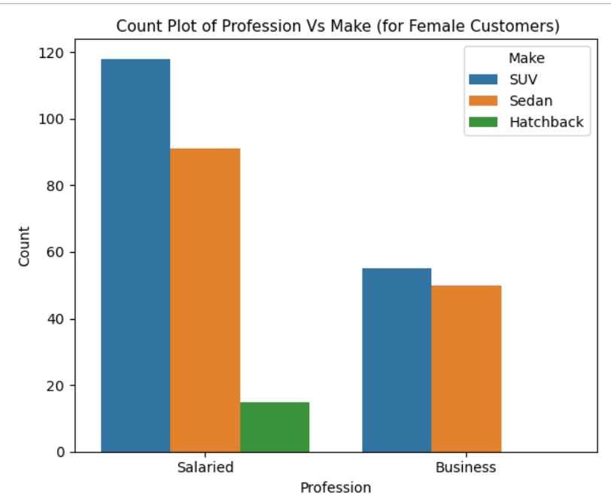

SUV is the most loved Car in Working Female Category & Hatchback is the least liked car in working women category.

Sedan is the second most loved car in Business Category & SUV also tops here also That means overall Female Likes SUV more than Males As there In income is more. So they like the most Costly car in the car Category.

**Insights and Recommendations**

**Gender-Based Insights**

* Females are generally older and tend to have higher base and total salaries.
* They are more likely to purchase higher-priced cars, especially SUVs, which are also the most preferred among salaried females.
* Recommendation: Design marketing campaigns for premium car models (like SUVs) targeted at working females, highlighting features like comfort, safety, and luxury.

**Profession-Based Insights**

* Salaried individuals prefer Sedans first, then Hatchbacks, while SUVs are the least preferred.
* Business owners show more interest in SUVs, likely due to higher disposable income and status-driven choices.
* Recommendation:
  + Promote economy variants of Sedans and Hatchbacks for salaried professionals.
  + Highlight prestige, spaciousness, and durability of SUVs for business buyers.

**Marital Status Insights**

* Married buyers have higher total salaries and spend more on car purchases.
* Single buyers have similar salary levels but lower total income.
* Recommendation: Bundle family-friendly features or EMI-based offers for married buyers, and emphasize affordability and style for singles.

**Education-Based Insights**

* Postgraduates earn more and have higher total salaries.
* However, graduates spend more on cars despite earning slightly less.
* Recommendation: Focus marketing on value-driven messaging for postgraduates and offer aspirational branding for graduates who are willing to spend more.

**Loan & Salary Patterns**

* High salary earners (above ₹70,000) avoid personal loans.
* House loans are common among those with 2–3 dependents.
* Buyers with a working partner have higher total income.
* Recommendation: Offer cash discounts or exchange offers to high-earning customers; target working couples with dual-income family packages.

**Car Type Preferences**

* SUV: Preferred by buyers aged 38–50 and earning ₹62k–₹82k.
* Sedan: Popular among 27–37-year-olds, earning ₹52k–₹68k.
* Hatchback: Chosen by 25–28-year-olds, with salaries between ₹44k–₹66k.
* SUVs have the highest total salary bracket (₹66k–₹1.2L) and cost more.
* Recommendation:
  + SUV ads should target older, affluent buyers.
  + Sedan and Hatchback marketing should appeal to young professionals.

**Behavioral Insight**

* SUVs are more popular among females than males.
* Salaried individuals prefer Sedans, but also show a second preference for Hatchbacks.
* SUV is the least chosen by both salaried and business buyers due to its high cost.
* Recommendation: For Hatchbacks and Sedans, focus on cost-effectiveness, fuel efficiency, and EMI plans.

**Summary**

The analysis of customer data for Austo Motor Company reveals distinct buyer profiles based on gender, profession, marital status, and education. Females and postgraduates lean toward premium purchases like SUVs, while salaried individuals and younger buyers prefer economical options like Sedans and Hatchbacks.

To optimize the current marketing strategy:

* Target working women and business owners for premium SUVs.
* Highlight affordability and efficiency for salaried youth.
* Use demographic segmentation to align car promotions with income, age, and lifestyle preferences.